Direct Speech
The exact words that someone says are called direct speech. Quotation marks “ ” are used to set off direct speech.
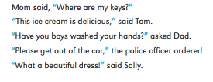
Indirect Speech
You can report what someone says without using their exact words. To do this, use a verb like say, ask or tell, followed by that. This is called indirect speech. There are several differences between a sentence with direct speech and a sentence with indirect speech.
- You don’t use quotation marks with indirect speech.
- You change the tense of the verb.
- You change the pronouns and determiners.
Here are some examples. The verb tenses that change are printed in bold and the pronouns and determiners that change are printed in colour. Remember that the past tense of can is could and the past tense of will is would.
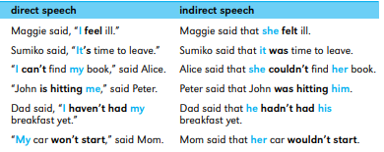
In indirect speech people often leave out the conjunction that.
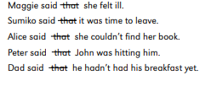
When you are using indirect speech to report a statement that is still true now, you don’t change the tense of the verb.
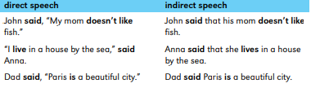
Indirect Commands
Use verbs like order, tell and warn to report orders and instructions. The construction to + verb or not to + verb may also be used.
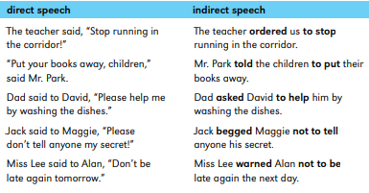
Indirect Questions
The verb ask is usually used to report questions.
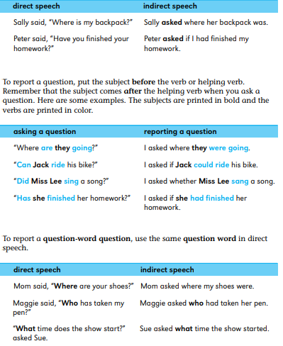
When you are reporting yes or no questions, use if or whether after the verb.
