Pronouns
A pronoun is a word that takes the place of a noun. There are different kinds
of pronouns.
Personal Pronouns
Personal pronouns may be used as:
- the subject of a verb, or
- the object of a verb.

Subject Pronouns

The subject of a verb does the action of the verb. The personal pronouns I, you, he, she, it, we and they can all be used as the subject of a verb.

Look at the following two sentences:

Lisa likes cats. She has four cats.

- In the first sentence, the proper noun Lisa is the subject of the verb likes.
- In the second sentence, the pronoun she is the subject of the verb has.

Here are some more pairs of sentences that show personal pronouns used
as subjects of verbs.
My name is Michael. I am fourteen.

My father works hard. He works in a factory.

My sister is older than me. She is twelve.

Our dog is very naughty. It likes to chase cats.

Bob, you are a bad dog!

David and I are playing football. We like sports.

Jim and Jeff are my brothers. They are older than I am.

Object Pronouns
The object of a verb receives the action of the verb. The personal pronouns me, you, him, her, it, us and them can all be used as the object of a verb.

Look at the following two sentences:

Lisa likes cats. She likes to stroke them.

In the first sentence, the noun cats is the object of the verb likes. In the second sentence, the pronoun them is the object of the verb stroke.

Here are some more pairs of sentences that show personal pronouns used as objects of verbs.

I’m doing my homework. Dad is helping me.

Goodbye, children! I’ll call you later.

Where is John? I need to speak to him.

Mrs Hussain is very nice. All the children like her.

The car is very dirty. Mum is cleaning it.

Uncle Harry called Mary to ask her a question.

My chocolates are all gone. Someone has eaten them.
First Person, Second Person and Third Person
In grammar, the person who is speaking is called the first person. The one spoken to is called the second person, and the one spoken about is called the third person.
Here is a table to help you remember which pronouns to use.
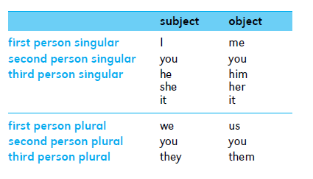

Reflexive Pronouns
Reflexive pronouns are words that refer to the noun or pronoun that is the subject of the verb. The words myself, yourself, himself, herself, itself, ourselves, yourselves and themselves are reflexive pronouns.

My brother built this computer himself.

Be careful not to cut yourself with that knife.

John was looking at himself in the mirror.

Kate fell and hurt herself.

Our cat washes itself after every meal.

We baked the cake by ourselves.

Come in, everybody, and find yourselves a seat.

The children cleaned their room all by themselves.

The bird washed itself by splashing in a puddle.

The players train every day to keep themselves fit.

Have yourselves a good time.

Here is a table to help you remember which reflexive pronoun to use with which personal pronoun.
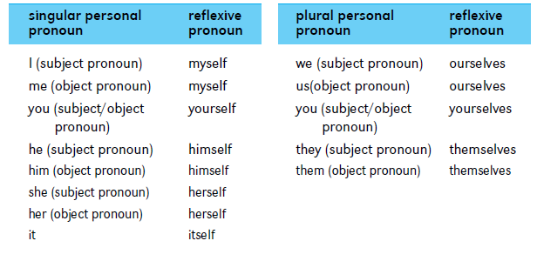
Possessive Pronouns
Possessive pronouns are used to talk about things that belong to people.
The words mine, yours, his, hers, ours and theirs are possessive pronouns.

This book is mine.

Have you lost yours, Tom?

This pen is mine and that one is his.

Sarah has lost her cat. Is this cat hers?

I can see our car, but where is yours?

We’ve had our lunch, but they haven’t had theirs.

Here is a table to help you remember which possessive pronoun to use with
which personal pronoun.
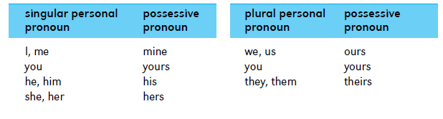
Demonstrative Pronouns
Demonstrative pronouns are used for pointing out things.
The words this, that, these and those are demonstrative pronouns.

This is my desk. These are my pets.

This is the Mings' house. These are sheep but those are goats.

That is my friend’s house. Those are horses.

That’s my mother’s car.

You’ll have to work harder than this.

We can do better than that.

It’s raining again. This is awful!

Who is that knocking at the door?

Hi, Kate. This is Michael.

Interrogative Pronouns
Interrogative pronouns are used to ask questions.
The words who, whose, what, which and whom are interrogative pronouns.

Who is dad talking to?

Who are those people?

Whose pen is this?

What is your brother’s name?

What is the date today?

Which of these desks is yours?

Indefinite Pronouns
An indefinite pronoun does not refer directly to any other word. Most indefinite pronouns express he idea of quantity.

Everybody is welcome at the meeting.

Many prefer their coffee with sugar.

Does anybody care for a cheese sandwich?

Few choose to camp out.
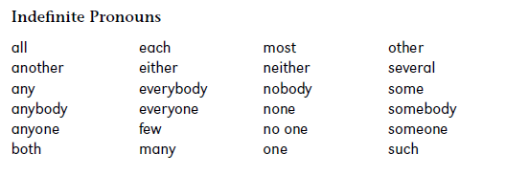
The pronoun they is considered an indefinite pronoun when it makes an indefinite reference.

Why don't they repair the bad roads?

