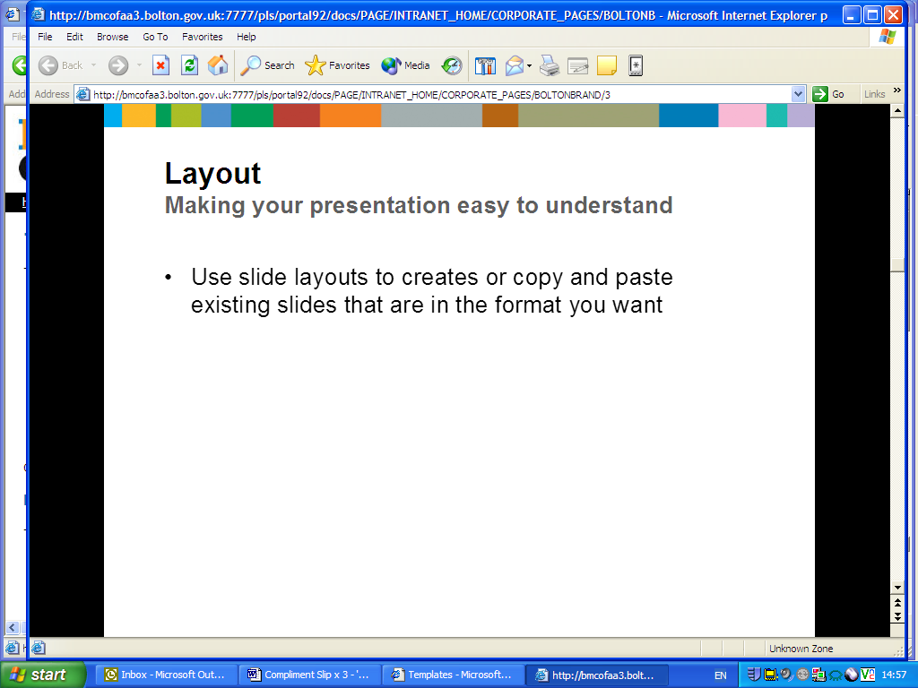

**Bolton Educational Psychology Service**

Newsletter – 24.04.2020

**Looking after yourselves and others**

Everybody has their own ways of coping in difficult times and all of us can learn additional ways to face challenges.

Below we describe some of the different ways children (and adults) cope. We offer simpleways parents can help their children to develop these skills during lockdown.

Families already have a lot to do, but you may want to pick a few suggestions and try them out for a week. If they do not work, do not worry, just try something else out the following week.

**Box 2: Online & Media Safety**

* Monitor children’s online interactions and media exposure and teach children online/media safety.
* Limit (but do not fully eliminate) the amount of time children (and adults) see media coverage of Covid-19. Encourage children to talk about anything that has worried them in media. Give age appropriate and honest answers; avoid too much detail.
* For child safety online guidance go to: <https://www.gov.uk/government/publications/child-safety-online-a-practical-guide-for-parents-and-carers/child-safety-online-a-practical-guide-for-parents-and-carers-whose-children-are-using-social-media>

Heading

Text

**B**elief

We can use belief systems and values to cope with challenges, e.g. by *trust in a higher power* or by *helping those most in need*. Belief systems are not just about religious beliefs. Many families of no faith will believe ‘we should *stay at home to stay safe, protect the vulnerable and help the NHS*. Ways to help your child could include:

* Talking with your children about their beliefs and values (or your values) and reasons for the current lockdown
* if they want to help others, perhaps working with them to raise awareness of an issue on social media or by getting them to call a lonely family friend
* connecting them with their faith community via trusted virtual platforms, if appropriate

**A**ffect (Emotions)

Expressing feelings can be a way to cope:, feeling bored or frustrated, laughing, crying or expressing a range of emotions. You can help your child by:

* telling them it is OK and normal to feel the way that they are feeling
* asking them how they are feeling, from time to time (see Box 1)
* letting them know you are there for them and listening.
* modelling calm and helpful expression of feelings and how to deal with them. e.g. ‘I feel frustrated, I’m going to breathe deeply’
* having fun every day: watch funny YouTube clips together or have a ‘dance off’

**S**ocial

Some people cope by interacting with and seeking help from other people. Families are central to this; however, children and especially older children, benefit from the social support of peers. You could help your child by:

* encouraging your child to connect with family and friends using social media platforms. Set this up for younger children (see Box 2)
* tell your child that it is OK to seek help when they are struggling
* model seeking help when it is needed (e.g. asking for help with tidying or asking a neighbour to help you get some essentials, if needed)
* spend time with each other every day, for example, eat meals together or play a game

**Box 1: Talking about our feelings without dwelling on negatives**

Parents comfort and help their children when they are feeling bad and this helps their emotional development. However, at other times you may want to support your child’s emotional development without dwelling on negative emotions. Here are some questions you can ask instead:

* In the last week when did you feel most happy?
* What makes you feel calm?
* Tell me what you want to do in the future?
* Tell me where in the house you feel most relaxed?
* Can you think of anything fun we can do at home?
* What have you enjoyed about today?

**Box 3: Seek help if needed, do not delay**

For mental or physical health emergencies please call **999**. For other concerns please follow the most up to date government guidance which can be found at [www.gov.uk](http://www.gov.uk). For further information on supporting children’s mental health please go to <https://www.gov.uk/government/publications/covid-19-guidance-on-supporting-children-and-young-peoples-mental-health-and-wellbeing/guidance-for-parents-and-carers-on-supporting-children-and-young-peoples-mental-health-and-wellbeing-during-the-coronavirus-covid-19-outbreak>

**I**magination

People, including adults can use their imagination to cope with difficulties. You can help your child by:

* reading or telling stories about overcoming challenges
* listening to or making music
* art projects (which could include *draw how I feel*)
* making up and acting out a play
* encouraging play as distraction and as a way of dealing with feelings
* giving your child free time to play each day
* creating a space free of electronics or structured games
* joining their play some of the time, but also letting them play alone
* modelling imaginative play, for example, for younger children, using toy dolls as props, act out a scenario of how the dolls are dealing with *feeling bored* or *feeling frustrated*
* ask your child to tell you what they are looking forward to doing when this is all over

**C**ognitive (Thinking)

Some people want to understand the issue and think about how they can overcome difficulties or they keep learning other things to distract themselves. You can help your child by:

* giving them age appropriate, clear and honest answers
* teaching them how to distinguish between reliable news and fake news (a great skill for life)
* explaining social distancing rules, e.g. why to wash hands regularly
* explaining your own coping strategies
* doing some online research and learning about stress reduction strategies together

**Ph**ysiological

Using our bodies and looking after them is another way to cope with stressful situations. Some of the ways to help our children include:

* follow an exercise routine every day, there are lots of free online exercise videos
* taking a daily walk with children (Listen to your child carefully at this time as they might be more willing and able to talk whilst walking)
* teaching deep breathing techniques (e.g. ‘take 10 deep breaths’ or ‘blow out 100 imaginary candles’)
* eating as healthily as possible
* drinking lots of water
* encouraging good sleeping habits (see links via Box 3)

*The ideas outlined above are based on the work of Professor Lahad.*

**[1]**

Having a routine generally helps with coping. Try to plan in things for yourself and your child that you know you will enjoy, that make you feel you have achieved something and that link you with others or with each other.

(drawing on approaches to behavioural activation)

The Educational Psychology Service can help with additional information, references and suggestions. Please contact our service or speak to your school SENCo.

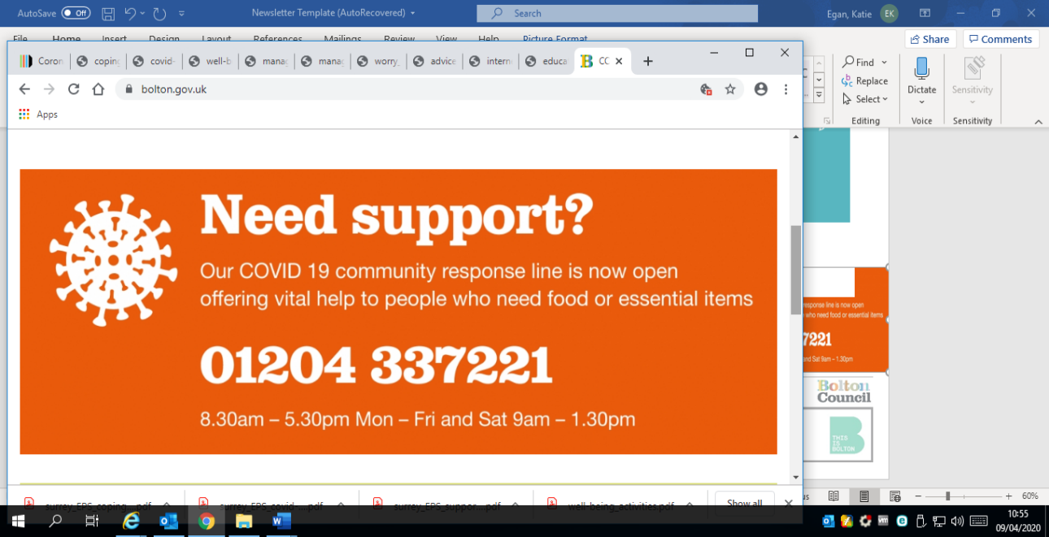

**Educational Psychology Service**

**Schools ICT**

**Smithills Dean Road**

**Bolton**

**BL1 6JT**

**Telephone: 01204 338060**

1.