Adjectives Worksheet

Adjectives describe nouns and pronouns. They give you more information about
people, places, and things.

Kinds of Adjectives.

Some adjectives tell about the size of people or things.

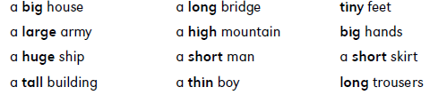

Some adjectives tell about the colour of things.

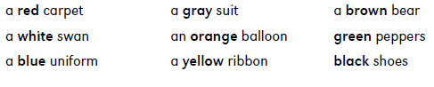

Some adjectives tell what people or things are like by describing their quality.

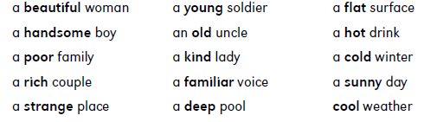

Some adjectives tell what things are made of. They refer to substances.

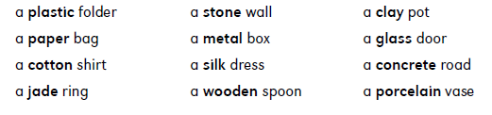

Some adjectives are made from proper nouns of place. These adjectives are called adjectives of origin.

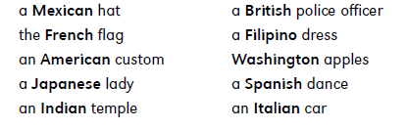

The order of adjectives.

Sometimes several adjectives are used to describe a single noun or pronoun. When you use two or more adjectives, the usual order is: size, quality, colour, origin, substance. For example:

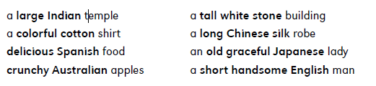
Adjectives of quality sometimes come before adjectives of size.

For example:

Beautiful long hair. Elegant short hair.

But adjectives of size always come before adjectives of colour. For example:

Beautiful long black hair. Elegant short red hair.

If you use any adjective of substance, it comes after the colour adjective.

For example:

A beautiful long black silk dress.

Adjective Endings
Adjectives have many different endings.

Some adjectives end in -ful. These adjectives describe noun or pronouns that are full of something or have a lot of something.

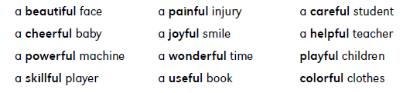

Some adjectives end in -ous.

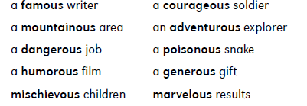

Some adjectives end in -y.

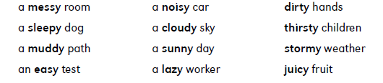

Some adjectives end in -less. These adjectives describe a person or thing that
does not have something.

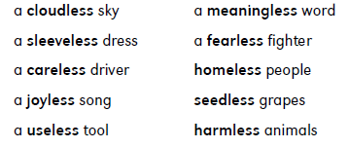

Some adjectives end in -al.

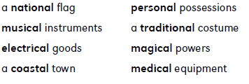

Here are some adjectives that end in -ic, -ish, -ible, -able, -ive and -ly.

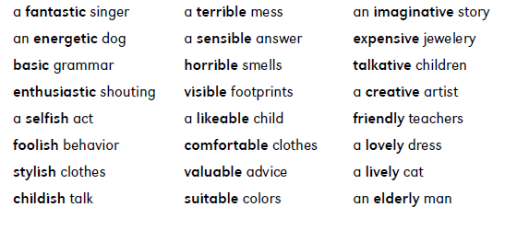
Many adjectives end in -ing.

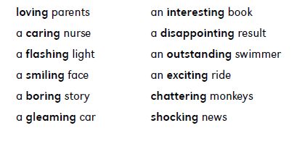
Words like smiling, caring and flashing are present participles of verbs. They are formed by adding ing to the verbs. Many present participles can also be used as adjectives.

Many of adjectives end in ed.

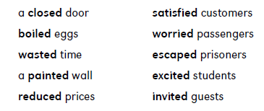

Describing What Something Is Made Of

Some nouns can be used like adjectives. For example, if you have a chair that is made of plastic, you can use the noun plastic as an adjective and say that the chair is a plastic chair. If you have a watch that is made of gold, you can say it is a gold watch.

But the nouns wood and wool can’t be used like this. To make adjectives of these nouns you have to add en.

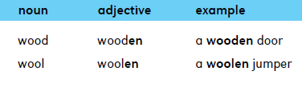

Describing What Something Is Like
There’s another way to make adjectives from nouns. Suppose you want to say that something is like a certain material, although not made of it. To make these adjectives, add -en to some nouns and -y to other nouns.

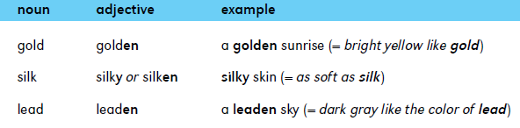

The Comparison of Adjectives

To compare two people or things, use the comparative form of an adjective. The comparative form is usually made by adding er to the adjective.

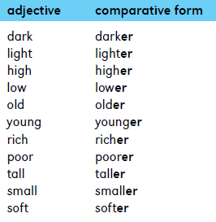

The Superlative Form
When you compare three or more people or things, use the superlative form of an adjective. The superlative form is usually made by adding est to the adjective.
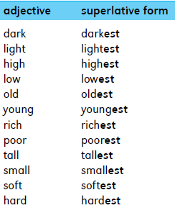

If the adjective ends in e, add r to form the comparative and st to form the superlative.

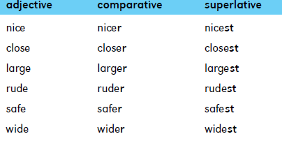

Suppose the adjective is a short word that ends in a consonant and has a single vowel in the middle. Just double the consonant and add er to make the comparative and est to make the superlative.

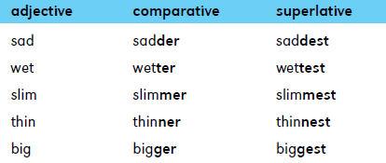

Suppose the adjective has two syllables and ends in y. Just change the y to i and add er to make the comparative and add est to make the superlative.
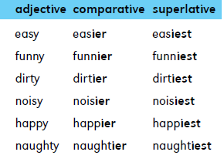
Use more and most to compare most other two-syllable adjectives. You will also use more and most with all adjectives that have more than two syllables.

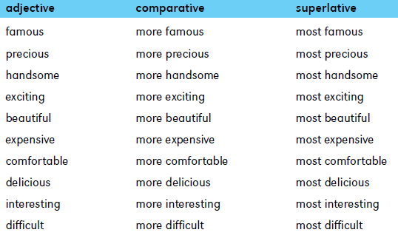

Irregular Comparative and Superlative Forms
A few adjectives don’t form their comparative and superlative forms in any of the usual ways. The comparative and superlative forms of these adjectives are different words, called irregular forms.
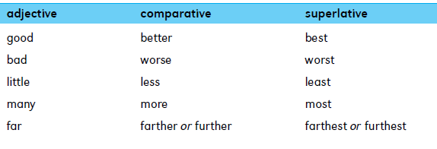
For example:

My painting is good, Melanie’s painting is better, but Andrew’s painting
is the best.

Adjective Phrases
Phrases can be used like single adjectives to describe nouns and pronouns.

Phrases that are used in this way are called adjective phrases.
Most adjective phrases come after the word they describe. Look at these examples. The adjective phrases are in bold and the nouns they describe are in colour.

Who is the girl with long hair?

My friend lives in the house across the street.
Mrs. Morris is tall and slim.

This is the road to Bolton.

The lady in the bookshop is a friend of mine.

Some adjective phrases come before the word they describe. The words in these phrases are often joined with hyphens.

a long-legged bird

an eight-year-old child

