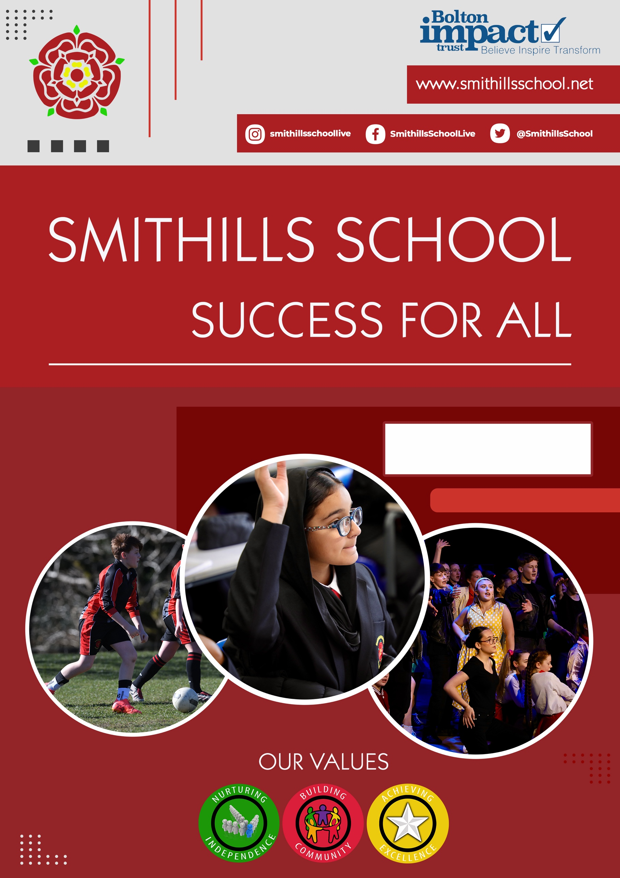

Receptionist / Administrator Candidate Information

Welcome to Smithills School
Thank you for expressing an interest in the position of Receptionist / Administrator. This is a wonderful opportunity to join our successful, over-subscribed 11-16 school at an exciting stage of our journey.
Smithills School is proud to be part of Bolton Impact Trust, a small, values-driven multi-academy trust comprising:
- Youth Challenge
- Lever Park
- Forward Centre
- Park School
Although each school within the Trust serves a different setting, we share a common vision and a strong set of values. Bolton Impact Trust is committed to pupil-centred, inclusive education and has consistently fostered a culture of collaboration and mutual support that reflects our own ethos.
As Headteacher I am fortunate to work alongside our talented staff, pupils, families and community partners. Our school is a very special place where we respect individuality, diversity and difference. Every child who joins us is encouraged to achieve and every adult who joins our team is given the opportunity to contribute.
Our values of Excellence, Independence and Community are evident in all that we do. They combine to ensure our vision of ‘Success for All’ is achieved.
In September 2023, just two weeks into my headship, the school was rated as ‘Requires Improvement’ in both Quality of Education and Leadership and Management but was judged as ‘Good’ for Personal Development, and Behaviour and Attitudes. Ofsted acknowledged that ‘pupils are warmly welcomed and quickly settle into school life,’ praised our ‘high aspirations for pupils’ achievement,’ and highlighted that ‘staff feel happy and proud to work’ at the school. They affirmed that we are heading in the right direction with the changes we are making, noting that more time is needed to fully implement and embed these improvements.
Since then, we have had a very positive monitoring visit, leaving us with only one Area for Improvement (AFI). Ofsted's feedback included that across curriculum areas, subject leaders have clearly identified the essential knowledge pupils must learn and the order in which it should be taught. Additionally, disadvantaged pupils and those with special educational needs and/or disabilities (SEND) are benefitting significantly from these efforts.
Our pupils are at the heart of everything we do. We are committed to developing and nurturing every child, providing the very best standards of education through a strong, knowledge rich curriculum, which is built around our expectations that all pupils will develop their depth of understanding across a wide range of subjects, securing an ambitious education for all. We also offer our pupils a wealth of cultural experiences, broadening horizons and developing self-esteem which provides them with the skills to make positive contributions to society, now and in the future.

We are committed to the continued professional development of all our colleagues and take our responsibility to develop leaders of the future seriously. We are equally committed to staff wellbeing: we provide a package of support to help all colleagues achieve a happy work life balance and we have a thriving wellbeing group that initiates real change in school.

If you are a dynamic, motivated, conscientious professional who has a passion for working with children and young people and you feel you have the skills and personal attributes to work as part of an innovative, energetic and ambitious team, we would love to hear from you.

Why work at Smithills?
As a team, we value every member of staff – from the site team to middle leaders, from teachers to SLT, from canteen staff to teaching assistants, from pastoral staff to IT support. We know that every person on our staff is crucial to the strategic development and the operational work of our school. As such, we promote well-being and prioritise manageable workloads in the following ways:
- SLT are supportive and highly visible around our site
- Teachers have their own classrooms
- We are committed to the Education Staff Wellbeing Charter
- Staff wellbeing is prioritised with free access to our swimming pool, gym, ‘Friday football’ and all sports centre activities during the week and at weekend
- The Staff Wellbeing Team includes broad representation from teaching and associate staff
- This team meets at least every half term, capturing staff voice and responding with concrete actions
- Teaching staff typically have above the national expectation of 10% of Planning, Preparation and Assessment (PPA) time
- Every teacher has a protected Professional Development hour every fortnight
- CPD is a regular feature of our calendar and includes teaching and support staff
- Opportunities for career development are embedded in our structures and systems
- Early Careers Teachers thrive in a supportive and caring environment. They have access to a broad and individualised programme of professional development
- As part of our commitment to continuous professional development all staff are encouraged and supported to undertake further study
- Internal applications for a range of roles are actively encouraged
- Data entry points are kept to a minimum for each year group
- Every department has high quality 5-year curriculum plans in place
- Departmental marking policies have been designed to actively reduce marking workload
- All teaching staff have an iPad/laptop
- The correction system is centralised
- Lunch duties are paid
- Reprographics is centralised
Most of all, though, we offer something which a bullet point list cannot capture: our staff and students are friendly and fiercely loyal to our school. Our school is a community and we are proud of that.
‘Leaders at all levels carefully consider the impact of any changes that they make to school systems which may affect the workload and well-being of staff’.

OFSTED
September 2023

We encourage you to come and see our school for yourselves. Please contact the Headteacher’s PA, Chris Shaw on 01204 842382 ext. 104 or c.shaw@smithillsschool.net to arrange an appointment. A member of SLT will be only too happy to show you around.
Closing date for applications: Tuesday 9th June 2026 at 9:00am

Interview date: Friday 15th June 2026
Receptionist / Administrator
Salary: Grade D pt 6-11 £25,989 – £28,142 pro rata
Actual Salary at pt 6 £
32.5 hrs per week over 5 days Term Time Only
Permanent Position

Job Description

Primary Purpose of the Job: To assist the Office Manager to provide reception and administrative support in school to ensure school fulfils its primary purpose both effectively and efficiently.
Responsible to: Office Manager
Principal Responsibilities: Provision of an effective and efficient reception support service within school, working to agreed quality and performance standards to deliver an efficient front of school reception service for customers.
The Receptionist plays a vital role in promoting the welfare of children and young people, ensuring a consistently high standard or work and professionalism, always maintain strict confidentiality and professional conduct.

Main Duties and Responsibilities

Reception:
- To provide a professional, welcoming and efficient reception and administrative service for Smithills School. The postholder will be the first point of contact for visitors, pupils, parents and carers, and will provide a wide range of administrative support to ensure the smooth day-to-day operation of the school.
- Operate the visitor management system, ensuring all visitors sign in and out and that safeguarding protocols are followed at all times.
- Issue and collect visitor and contractor badges in line with the school's safeguarding procedures.
- Answer and direct telephone calls promptly and professionally, taking accurate messages where required.
- Manage incoming and outgoing correspondence, including post, emails and deliveries.
- Maintain a calm and orderly reception environment at all times.

Administrative Support:
Providing administrative support to the Main Office, ability to multi-task and prioritise workload.
Record Keeping:
Signing in visitors and ensuring accurate information is recorded.
General Duties:
Handling mail, maintaining a clean and organised reception area, ensuring compliance with policies related to child protection, health and safety, confidentiality and data protection.
To deliver and co-ordinate a reliable reception service and develop customer relationships.

Administration
To plan and manage your work to meet specified deadlines and requirements.

Responsibilities
To work effectively with other team members to contribute to improving the work of the team.
To build effective working relationships, both within the school and with partner agencies, to develop effective services.
To be aware of and comply with policies and procedures relating to child protection, safeguarding, health and safety and security, GDPR, confidentiality and data protection, reporting all concerns to an appropriate person.
Contribute to the overall ethos, work and aims of the school.
Appreciate and support the role of other professionals.
Attend and participate in relevant meetings as required.
This role is primarily based at the main school reception and administrative office. The postholder will work in a busy, public-facing environment and may occasionally be required to move around the school site to deliver messages, escort visitors or carry out other duties.
Safeguarding
Smithills School is committed to safeguarding and promoting the welfare of children and young people and expects all staff and volunteers to share this commitment. Successful candidates are subject to an enhanced disclosure from the Disclosure & Barring Service.
Current or previous employers will be contacted as part of the verification process pre-appointment checks if the applicant is short-listed. Information requested will include:

- Disciplinary offences relating to children, including any which the penalty is “time expired”
- Whether the applicant has been the subject of any child protection concerns
- The outcome of any enquiry or disciplinary procedure

Any discrepancies or anomalies in the information provided or issues arising from references will be taken up at interview.

We may use internet searches using information held in the public domain to perform due diligence on candidates in the course of recruitment, in terms of suitability for the post applied for. Where we do this, we will act in accordance with our data protection and equal opportunities obligations.

The post holder may reasonably be expected to undertake other duties commensurate with the level of responsibility that may be allocated, at the discretion of the Headteacher and to meet the needs of the school.

Additional language would be advantageous.

Person Specification

Stage One
The minimum essential requirements for the above post are as follows. Please try to show in your application form, how best you meet these requirements. Disabled candidates are guaranteed an interview if they meet the essential criteria.

Skills and Knowledge |  | Method of Assessment
 | Demonstrate the ability to develop, implement and maintain quality administrative services to customers. | Application Form / Interview
 | Demonstrate the ability to work effectively as part of a team and under own supervision using initiative. | Application Form / Interview
 | Demonstrate the ability to multi-task, plan, develop, organise and prioritise your work to meet deadlines and changes in priority. | Application Form / Interview
 | To demonstrate the ability to organise, support and maintain the use of information technology systems and software. | Application Form / Interview
 | To be able to manage and organise the ordering, storage and distribution of specified goods and services | Application Form / Interview
 | An understanding of the services provided by the school | Application Form / Interview
 | An awareness of relevant legislation/good practice relating to schools, particularly safeguarding | Application Form / Interview
 | Competencies  Please note the school’s competencies, which are essential for all roles, are in the attached Core Competencies document. | Interview
 | Excellent written and verbal communication skills | Interview
 | Ability to prioritise and manage a varied workload. | Interview
 | Professional, warm and welcoming manner with staff, pupils, parents and visitors | Interview
- Calm | Calm under pressure with the ability to remain composed in a busy environment. | Interview
 | Highly organised with strong attention to detail. | Interview
 | Discreet, trustworthy and able to maintain confidentiality at all times. | Interview
 | Flexible team player willing to support colleagues across the admin team. | Interview
 | Positive, can-do attitude and commitment to the school’s values and ethos. | Interview
 | Community to equality, diversity and inclusion. | Interview

Experience, Qualifications and Training |  | Method of Assessment
 | NVQ Business and Administration Level 3 or equivalent. | Application Form / Certificate
 | Experience of using a range of computer software packages and systems | Application Form
 | Additional language would be advantageous | Application Form

Work Related Circumstances |  | Method of Assessment
 | The nature and demands of the post holder’s time are not always predictable and there will be an expectation that work will be required outside normal hours from time to time. | Interview
 | This post is subject to enhanced disclosure from the Disclosure and Barring Service. | Application Form / Certificate

Stage Two
This will only be used in the event of many applicants meeting the minimum essential requirements. Please try to show in your application form, how best you meet these requirements.
Skills and Knowledge |  | Method of Assessment
 | Evidence of continuous development. | Application Form
 | Previous experience in a reception or customer facing administrative role. | Application Form
 | Experience of working in a school or education setting. | Interview
 | Proficient in the use of Microsoft Office applications (Word, Excel, Outlook) | Interview
 | Experience of managing a busy telephone switchboard. | Interview

Experience, Qualifications and Training |  | Method of Assessment
 | To have experience of using initiative to enhance performance. | Application Form

