Auxiliary Verbs
Exercise 1
Complete the sentences below by writing can or can’t on the blanks.
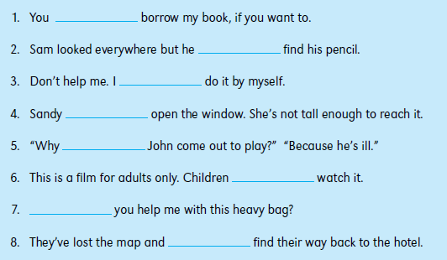
Exercise 2
Complete the sentences using would or wouldn’t with a verb from the list below. The
first one has been done for you.
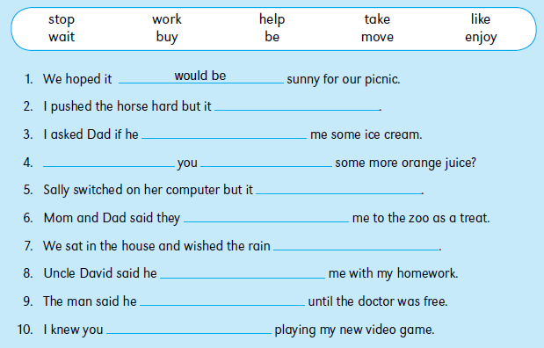

Exercise 3
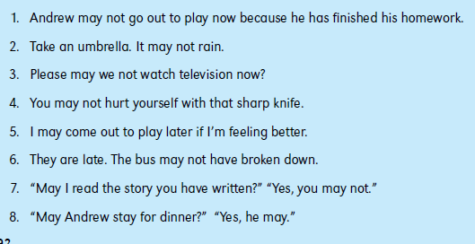
Tell whether each sentence below uses may or may not correctly.

Exercise 4
Complete the sentences using should or shouldn’t and a verb from the list below.
The first one has been done for you.
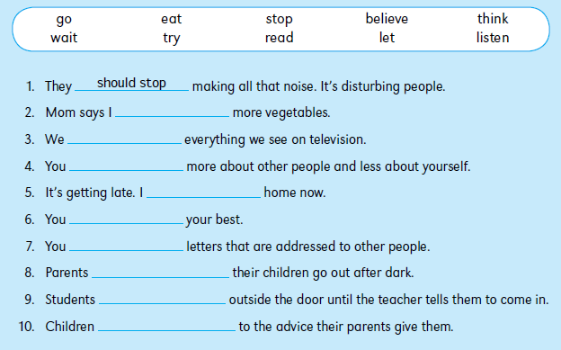
Exercise 5
Now rewrite the sentences from Exercise 4 above, using ought to or ought not to.

Exercise 6
Complete the sentences using must or mustn’t with a verb from the list below. The first
one has been done for you.
