Sentences Worksheet
A sentence is a group of words that expresses a complete thought. Sentences always have a subject and a verb.
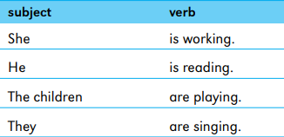
Four Kinds of Sentence
A declarative sentence makes a statement.
- It is raining.
- Tom likes football.
- The school bell was ringing.
- The children are playing with the dog.
- An interrogative sentence asks a question.
- Where are my keys?
- Why is the sky blue?
- Who is talking to the teacher?
- Is this the way to the ice skating rink?
An exclamatory sentence makes a very strong statement called an exclamation. It shows a strong feeling such as surprise or anger.
- What a kind thing to do!
- How beautiful she is!
- The silly boy!
- A declarative sentence ends with a full stop.
- An imperative sentence gives an order.
An imperative sentence gives an order.
- Ask Tom to come and see me.
- Don’t tell me lies.
- Please leave.
- Go to your room!
- Speak up!

N o t e s
A declarative sentence ends with a full stop.
N o t e s
An interrogative sentence ends with a question mark (?)
N o t e s
An exclamatory sentence ends with an exclamation mark (!)
N o t e s
An imperative sentence can end with an exclamation mark (!) if the order is very firm.

Sentences with Objects
The subject of a sentence often does something to another person or thing. The person or thing that receives the action of the subject is called the object of the verb. Verbs that have objects are called transitive verbs. Here are some sentences with transitive verbs.
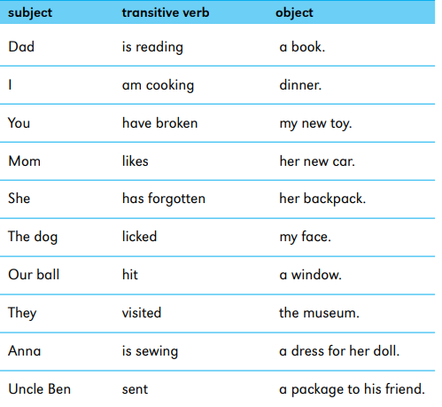
Verbs with Two Objects
Some verbs have two objects. Look at the sentence below.
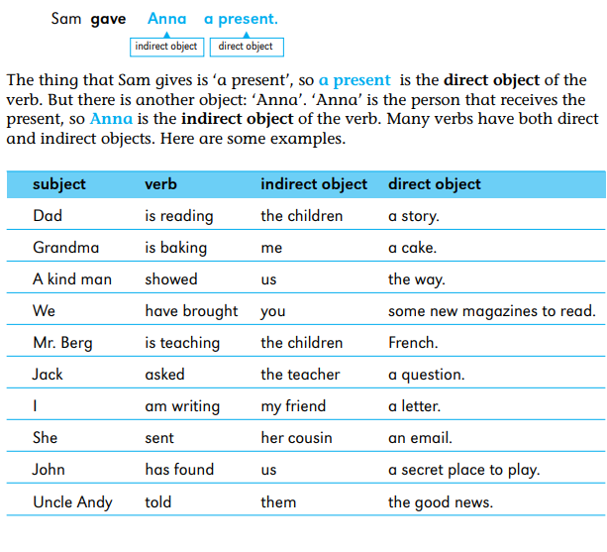
Verbs with No Object
Some verbs don’t have an object. A verb that does not have an object is called an intransitive verb. Here are some sentences with intransitive verbs.
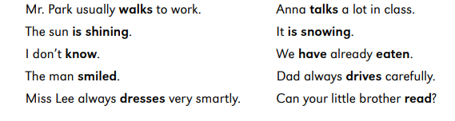
Simple Sentences
A clause is a group of words that contains one subject and one verb. A sentence that consists of one clause is called a simple sentence. Here are some examples. The subjects are printed in bold and the verbs are printed in colour.
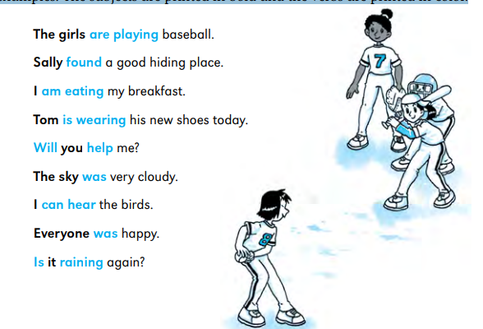
Compound Sentences
A compound sentence contains two clauses joined by a conjunction such as and, or, but or so. Look at these examples. The verbs in the clauses are printed in colour. Notice that there are two verbs, one on each side of the conjunction.
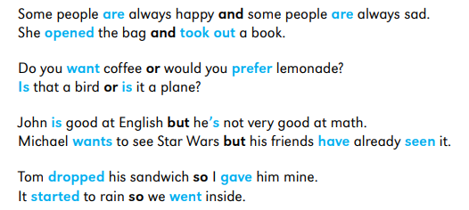
Conditional Sentences
To talk about things that are possible, you often use if in a sentence. A sentence with if is called a conditional sentence. Here is an example of a conditional sentence with the if-clause printed in colour.
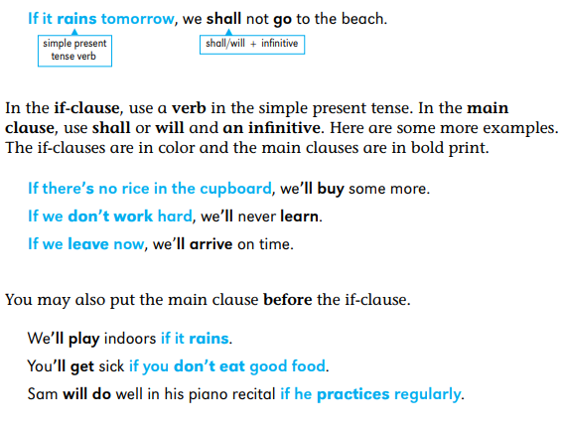
Positive and Negative Sentences
A positive sentence tells you about something that exists or something that is happening.
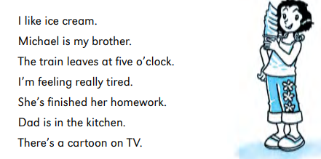
A negative sentence contains the word not or another negative word. Negative sentences tell you that something does not exist or is not happening. Here are some examples. The negative words are printed in bold.
Tom isn’t as tall as Alan.
We didn’t hear you shout at us.
Meera hasn’t read the Harry Potter books.
People can’t see very well in the dark.
There’s nothing interesting on TV tonight.
We’ve never been to China or Japan.
Nobody knows my secret.
There are no coins in my pocket.
I’m not very strong.

Questions
There are two kinds of questions: yes or no questions and question-word questions.
Yes or no questions.
When you ask a yes or no question, you want the answer yes or the answer no. Use the verbs be, have and do along with helping verbs such as can, will and should when you ask these questions. Here are some examples of yes or no questions, with answers.
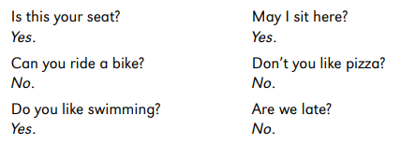
In questions, the helping verb comes before the subject. The other verb comes after the subject. The verb be also comes before the subject when it is an ordinary verb rather than a helping verb. Here are some examples of statements and the questions you can make from them. Notice that the helping verbs are printed in bold and the subjects are in colour.
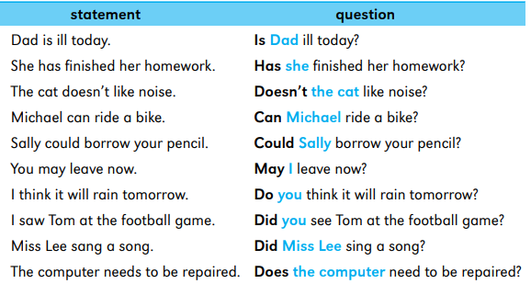

Question-word questions
These use the question words what, which, who (sometimes whom), whose, when, where and how to ask for information. The verbs be, have and do, and helping verbs such as can, will and should are also used in questions. The helping verb comes before the subject, as it does in yes or no questions. Here are some examples. Again, the helping verb is printed in bold and the subject is printed in colour.
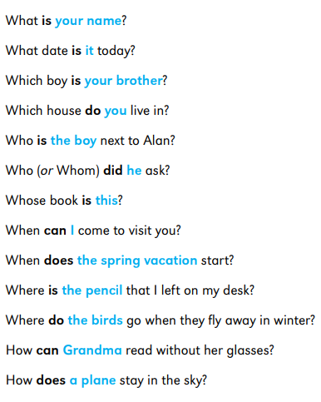
Sometimes the wh-word itself is the subject of the sentence. In this case, don’t use do to form questions.
Who wants to come with me?
What caused the accident?
Which is the fastest car?
I’ve got my coat.
Whose is this?

Question Tags
Sometimes people finish what they are saying with a short question. Why do they do this? Because they want to know if the person they are speaking to agrees with them. This short question is called a question tag. Look at the following sentence.
