Nouns Worksheet

There are two main types of nouns: common nouns and proper nouns.
Common Nouns

Words for people, places and things are called common nouns.

These common nouns are words for things.
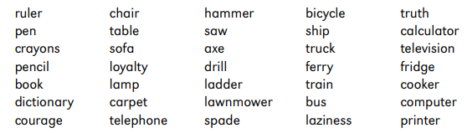

These common nouns are words for animals. Notice that special names for young animals are included.
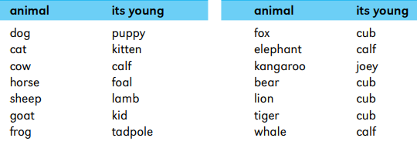

These common nouns are words for places.
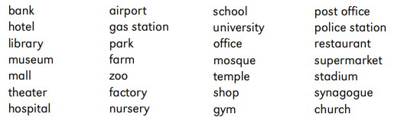

These common nouns are words for people who do certain things.
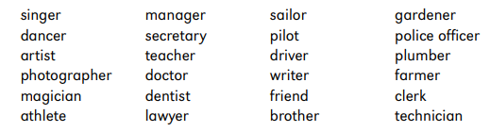

Proper Nouns

The names of particular people, places and things are proper nouns.

They always begin with a capital letter. These people’s names are proper nouns.

These people’s names are proper nouns.

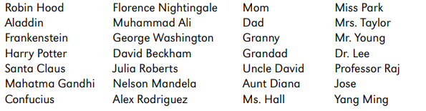

The names of the days of the week and the months of the year are proper nouns.
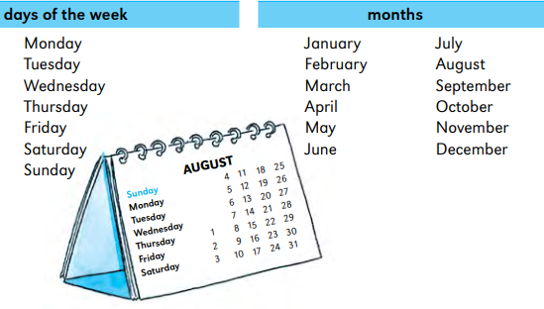

The names of special days and celebrations are also proper nouns.
- New Year’s Day
- Mother’s Day
- Valentine’s Day
- Halloween
- Christmas
- Ramadan
- Yom Kippur

The names of famous places, buildings and monuments are proper nouns.
- Big Ben
- the Empire State Building
- the Sphinx
- the Taj Mahal
- Old Trafford

The names of people who live in a particular country are also proper nouns.

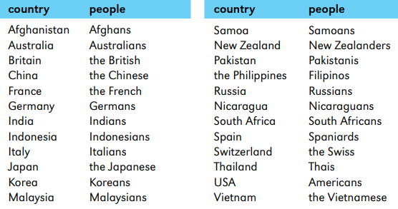

Singular Nouns

Nouns can be singular or plural.

When you are talking about just one thing or person, use a singular noun.

For example: a tent, a park, an idea, a taxi, a doctor, an oven, a house, a lady, an exercise.

Plural Nouns

Use a plural noun when you are talking about two or more people, places or things.

Just add s to make most nouns plural.
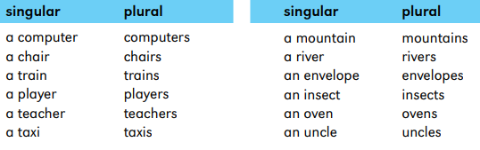

Nouns that end in s, ss, ch, sh or x, are made plural by adding es.
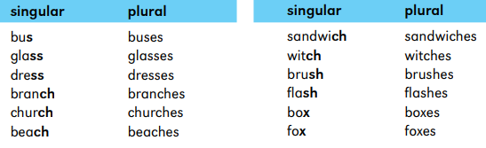
Most nouns that end in y are made plural by changing the y to i and adding es.

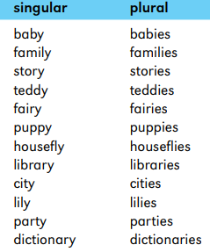

Many nouns that end in f are made plural by changing the f to v and adding es.

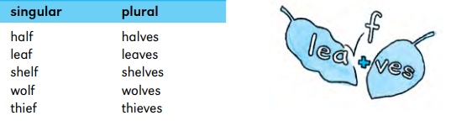

But some nouns that end in f are made plural simply by adding s.

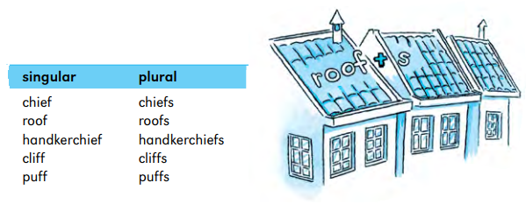

Some nouns that end in f can be made plural in two ways.
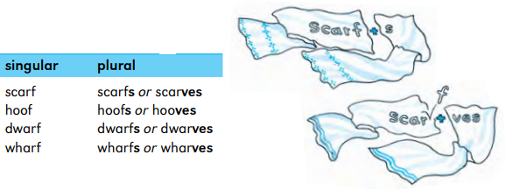

Most nouns that end in fe are made plural by changing the f to v and adding s.
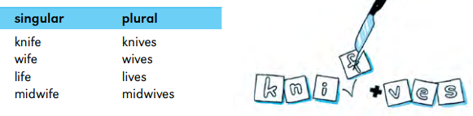
Most nouns that end in o are made plural by adding s.
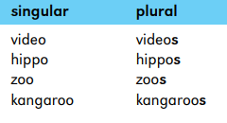
But other nouns that end in o are made plural by adding es.
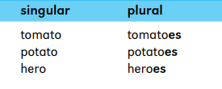
Some nouns change spelling from the singular form to the plural.
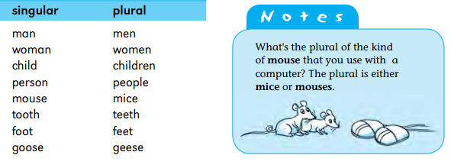
The plural form of some nouns is the same as the singular form.
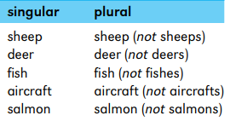
Some nouns are always plural.

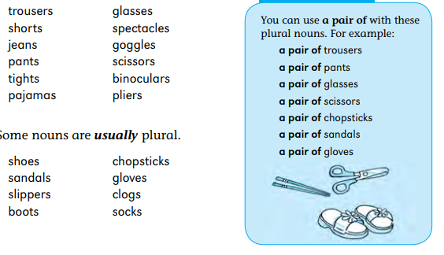
Collective Nouns
Words for groups of people, animals or things are called collective nouns.
Here are some collective nouns for groups of people.
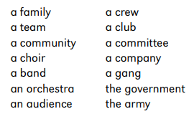

Collective nouns may be used with a singular verb or with a plural verb.
If the group is acting as a single unit, use a singular verb.

If group members are acting as individuals, use a plural verb. For example:

The crowd was orderly. or The crowd were clapping, yelling and cheering.

Here are more collective nouns you can use for groups of people.
- a crowd of shoppers
- a gang of thieves
- a company of actors
- a panel of judges
- a class of school children
- a platoon of soldiers

Many groups of animals have their own special collective nouns.
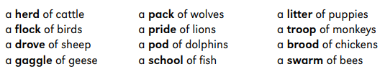
Some groups of things also have their own special collective nouns.

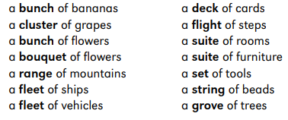
Some nouns name the amount or form of something.
- a loaf of bread
- a bar of soap
- a ball of string
- a bar of chocolate

The words a piece of mean a single serving or part of something.

