Verbs and Tenses Worksheet
Most verbs describe actions, so they are called action verbs. Action verbs tell
what people or things are doing. Here are some common action verbs.

drink look jump swim fall
eat shout walk throw climb
laugh run sit catch dance

Subject and Verb Agreement

When you use a verb, you have to say who or what is doing the action. This
‘who or what’ is the subject of the verb. The subject and the verb match each other. You say that the subject and the verb agree when they match each other.

Use a singular verb if the subject is a singular noun. For example, the subjects ‘my dad’ or ‘our school’, or any of the pronouns he, she or it, require a singular verb. Most singular verbs end in s. Look at the subjects and their verbs in these examples. The subjects are in bold and the verbs are in colour.

He always drinks milk when he’s hot.
She eats bananas for breakfast.
Mom walks to work every day.
My sister dances like a professional dancer.
The baby falls when she tries to walk.
Our cat climbs the trees in our garden.

This form of the verb is called the third person singular. You use it when the subject of the verb is not you or the person you are speaking to, but some other person—a third person—or a thing.

Here are some more third person singular verbs that end in s.

Plays sings shines rides smiles
draws paints blows thinks stops
reads rains travels talks starts

The third person singular form of some verbs is made by adding es at the
end. Some examples are verbs that end in sh, ch, ss, x, zz and o.
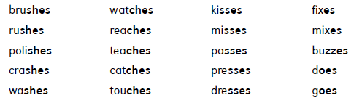
Here are some sentences with verbs in their third person singular form.
The subjects are in bold and the verbs are in colour.

She always brushes her teeth at bedtime.
Dad polishes his shoes until they shine.
My brother watches television after school.
Kim catches the ball with one hand.
Dad mixes flour and water when he makes bread.
The bee buzzes around the flowers.
My friend Sanjay goes to the same school as I do.

How do you make the third person singular form of most verbs that end in y?
Usually, you just change the y to an i and then add es.

carry – carries hurry – hurries copy – copies
cry – cries fly – flies marry – marries
study – studies worry – worries bully – bullies

A cat carries its kitten with its mouth.
Mr. Chen hurries to work every morning.
The baby cries a lot at night.
This plane flies to the island every day.
Alice tries hard at school.
She copies all the questions in her notebook.
Some verbs that end in y have a vowel before the y. Just add an s at the end of these words to make the third person singular form.

buy – buys say – says pray – prays
pay – pays annoy – annoys stay – stays

Mum buys bread at the supermarket.
Mr. Carter pays all his bills with a credit card.
My friend says he has a salt-water aquarium.
She annoys me with her silly jokes.
Anna stays with her aunt on weekends.

If the subject of a verb is a plural noun, such as “Mom and Dad” or “our teachers”, use a plural verb. Do not add s, es or ies to plural verbs. Plural verbs are also used with the pronouns I, we, you and they.

Mum and Dad love us.
My sisters listen to music a lot.
The stars shine brightly on a clear night.
Some people drink tea.
I like juicy hamburgers.
We learn interesting things at school.
You all know the words to this song, children.
They always walk home from school together.
Suppose the subject of a noun refers to a group of people. Depending on the
meaning of the sentence, you may use either a singular or a plural verb.
The audience was enjoying the play.
The audience have all gone home.
The class has thirty students.
The class are handing in their papers.
The band is performing until midnight.
The band were arguing among
themselves.
Transitive and Intransitive Verbs
Some verbs have an object. The object of a verb is the person or thing that is
affected by the action of the verb. Look at this sentence:
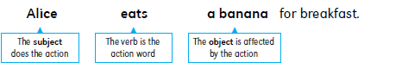
The subject of the verb is Alice. She is the person who does the action: she
eats. The object of the verb is a banana. A banana is affected by the action
of the verb. So in this sentence, the object of the verb ‘eat ’ is ‘a banana’.
Verbs that have objects are called transitive verbs.

Here are some sentences with transitive verbs. The verbs are printed in bold
and their objects are printed in colour.

John likes apples. Sam knows the answer to the question.
My sister cooks all our meals. My brother rides his bike in the street.
Dad buys tea at the market. Mom writes stories in her spare time.
Some verbs don’t have an object. A verb that does not have an object is called an intransitive verb. Here are some sentences with intransitive verbs.

In China, lots of people walk to work.
The boys play in the yard after school.
Mr. Carter always drives very carefully.
Doris is a very successful businesswoman.
Michael and I both entered the race. He won but I lost.

Some verbs can be either transitive or intransitive. Notice that the transitive meaning and the intransitive meaning are sometimes different.

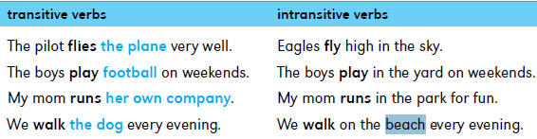

The Simple Present Tense
Verbs have forms called tenses that tell you when the action happens. If the action happens regularly, sometimes or never, use the simple present tense.

We always wash our hands before meals.
Joe sometimes lends me his bike.
Dad jogs in the park every day.
We often go to the movies on Satrurday.
Mr. Ross takes a train to work.

The simple present tense is also used to state facts.

The sun rises every morning.
Penguins live in the Antarctica.
Dogs love playing in water.
The earth goes around the sun.
Australia is an island.

Use the simple present tense to tell the events of a story that is happening now.

I arrive at school. I see another girl crying. I ask her why she is sad.
She says she hasn’t got any friends to play with. I tell her that she
can play with me.

Use the simple present tense to talk about things that will happen in the future.
My little sister starts school tomorrow.
The new supermarket opens this Friday.
Next week I go on holiday to Japan.
We fly to London on Sunday.
The train leaves in five minutes.
My family moves to a new house next month.

Am, is and are

The words am, is and are are the simple present forms of the verb be.
n Use am with the pronoun I.
n Use is with singular nouns like ‘my dad’ and ‘the teacher’, and with the pronouns he, she and it.
n Use are with plural nouns like ‘my parents’ and ‘Jenny and Mary’, and with
the pronouns we, you and they.

I am twelve. The children are asleep.
I am in the garden. Computers are very expensive.
My mum is very tired today. My brother and I are upstairs.
The teacher is tall. We are in our bedrooms.
She is also pretty. You are my best friend.
Our dog is black. You and David are my best friends.

Here is a table to help you remember how to use is, am and are.
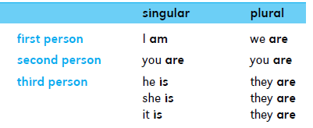
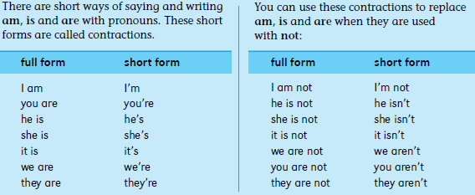

There is and there are
Use there with is and are to say what exists or what you can have. Use there is with singular nouns, and there are with plural nouns.

There is a tree in our garden.
There is a girl called Farah in my class.
There is fish for dinner.
There is nothing to do when it rains.
There’s a cat sitting on the bench.
There’s a boy in my class who can walk on his hands.
There are cows in the field.
There are some very big ships in the harbour today.

The Present Progressive Tense

The present progressive tense is used to talk about things that are continuing
to happen. Make the present progressive tense by using am, is or are with a verb that
ends in ing.

I am learning how to swim.
I am eating my lunch.
I am watching television.
She is reading a book.
Dad is baking a cake.
My sister is listening to music.
Uncle David is cleaning his car.
The dog is barking in the garden.
We are singing our favorite song.
My brother and I are playing a computer game.
The teachers are showing us a film.
They are bringing a television set into the classroom.

The present progressive tense is also used to talk about things that are
planned for the future.

I am going to the library tomorrow.
My sister is giving me her bike when she gets her new one.
We can’t go to the movies tomorrow because my mom is working.
We are having a barbecue on Sunday.
All my friends are coming to my party next week.
We’re taking my cousin to the zoo later today.

The Simple Past Tense
Use the simple past tense to talk about things that happened in the past.
The simple past tense is usually made by adding ed to the verb.

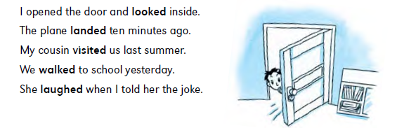
If a verb ends in e, just add d to make the simple past tense.
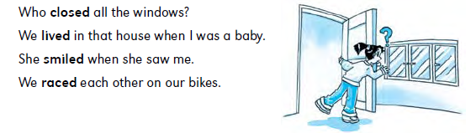
If a verb ends in y, change the y to i before adding ed.
I carried my mum’s shopping bag.
My brother cried when he fell off his bike.
We hurried to the station to catch the train.
Dad tried to help me with my homework.

With some short verbs that end in a consonant, you must double the consonant before adding ed.

I climbed over the fence and ripped my shirt.
The stranger grabbed my arm.
The dog wagged its tail when it saw the biscuits.
He slammed the door and walked off angrily.

Was and were
The words was and were are the simple past forms of the verb be.

n Was is the simple past form of am and is. Use was with singular nouns like
‘my dad’ and ‘the teacher’, and with the pronouns he, she and it.
n Were is the simple past form of are. Use were with plural nouns like ‘my
parents’ and ‘Jenny and Mary’, and with the pronouns we, you and they.

Ten years ago, I was only a baby.
When I was younger, I played with teddy bears.
My friend was ill yesterday.
Mom was angry when she saw the broken vase.
It was very wet on Monday.
It was six o’clock when we got home.
We were away on vacation last month.
John and I were in the garden.
You were nasty to me!
You and Sally were not at school yesterday.
Dinosaurs were prehistoric animals.
Those were my best jeans.

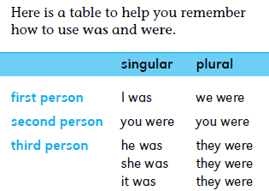

Irregular Verbs
Many common verbs have unusual present and past tense forms. These are
called irregular verbs.

Remember that the simple past tense of most verbs is made by adding ed at the end: look becomes looked. Notice that the simple past tense of these common irregular verbs is quite different.
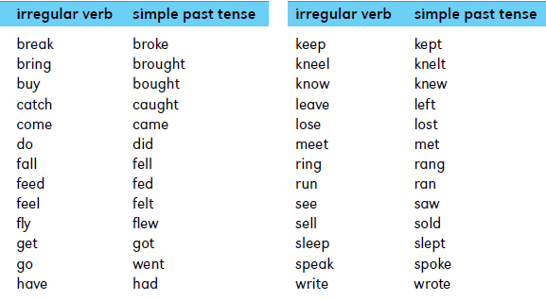

The simple past tense of other irregular verbs does not change at all.

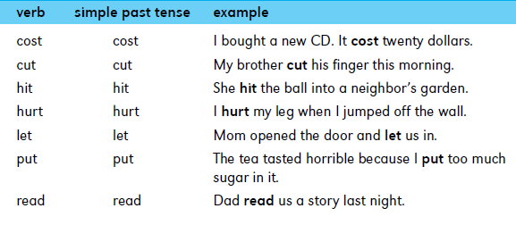
The Past Progressive Tense

Use the past progressive tense to talk about things that were happening in the past and had not stopped happening. They were continuing. To make the past progressive tense, use was or were and a verb that ends in ing.

- I was watching television.
- Ben was finishing his homework.
- She was putting her books into her schoolbag.
- Jenny and I were tidying the classroom.
- We were all dancing at the party.
- You weren’t listening to the teacher.
- Some boys were looking out of the window.

You can also use the past progressive tense to say what was happening when something else happened.

- Sam was doing his math homework when the phone rang.
- Dad was cooking our dinner when I got home.
- When I saw Joe, he was looking for his dog.
- We were all enjoying the movie when the power went out.
- What were they doing when the bell rang?

Have, has and had

The verb have is used to say what people own or possess.

- Use have with the pronouns I, we, you and they, and with plural nouns such as ‘my parents’ and ‘Tom and Susan’.
- Use has with the pronouns he, she and it, and with singular nouns such as ‘my dad’ and ‘the teacher’.

I have two brothers and one sister.
Monkeys have long tails.
My sister and I have a swing in our garden.
John has a big brother.
Sally has a pretty face.
An elephant has a long trunk. It also has big ears.
His brother has dark hair.
Our apartment has big windows.

Use have to talk about things that people do or get.

I can’t play football because I have a broken leg.
We have art lessons on Mondays.
You have a stain on your shirt.
They have the desks nearest the teacher.
Peter has a sore knee.

You also use have to talk about things that people eat.

We usually have lunch at school.
Mom and Dad sometimes have their breakfast in bed.
Jenny often has sandwiches for lunch.
She sometimes has cola to drink.

Here is a table to help you remember how to use have and has.
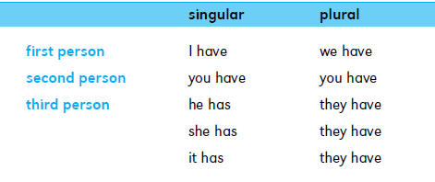

The simple past tense form of have and has is had.

I had a big toy car when I was small.
It was sunny so we had lunch in the garden.
They had a wonderful holiday in Europe.
Sally and I had chicken for dinner.
The boys had a fight in the playground.
Dad had a sore back yesterday.
She had long hair when I saw her a year ago.
Our cat had three kittens last week.

Use had when you're talking about wishes.

I wish I had a new bike.
Kathleen wishes she had a big sister.
Dad wishes he had a bigger garage.
The boys wish they had more space to play football in.

You can make the negative with didn’t have.

I wish I didn’t have so much homework.
Jack wishes he didn’t have a broken leg.
Dad wishes he didn’t have to work on weekends.
Do you wish you didn’t have English classes today?

The Present Perfect Tense

The present perfect tense shows action in the indefinite past. The present perfect
tense is also used to show action begun in the past and continuing into the present. To make the present perfect tense, use have or has and a verb that ends in ed.

We have lived in this house for five years.
(= and we still live there)

Your plane has already landed.
(= and it’s still on the ground)

She has dirtied her new shoes.
(= she made them dirty and they’re still dirty)

The teacher has pinned a notice on the board.
(= and the notice is still there)

You don’t need your key. I’ve already opened
the door. (= and it’s still open)

Irregular Past Participles
Remember that irregular verbs don’t have a simple past form that ends in -ed. Irregular verbs also have unusual past participles that don’t end in -ed. The past participle of some verbs is the same as the simple past tense.

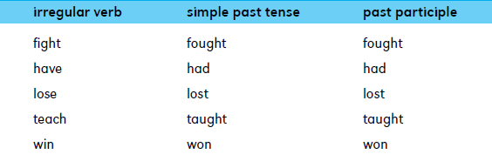
Here are more examples of irregular past participles.

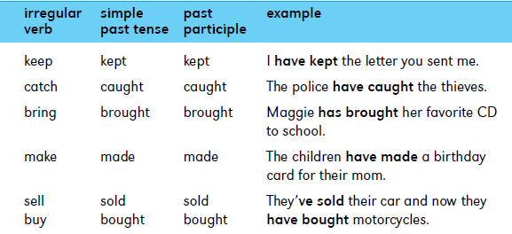

Some common irregular verbs have a past participle that is different from
the simple past tense.
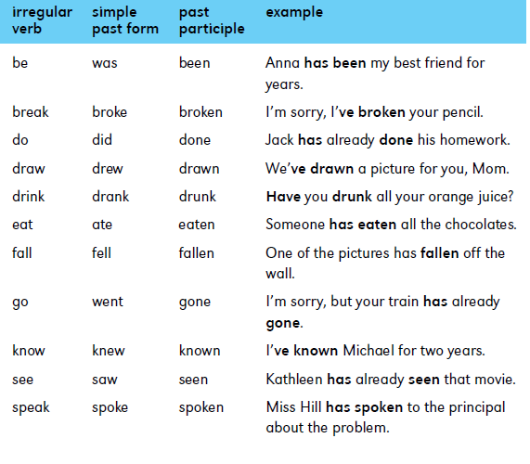

Some irregular verbs have a past participle that does not change at all.

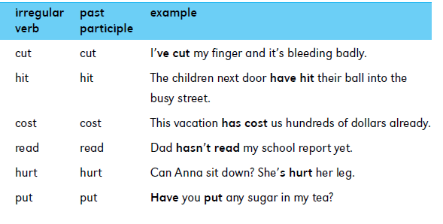
The Future Tense
To show future action use the verbs shall and will with another verb that
describes the action.

- You can use either shall or will with the pronouns I and we.
- Use will with the pronouns you, he, she, it and they.
- Will is also used with singular nouns like ‘my dad’ and with plural nouns like ‘all the boys in my class’.

I shall do my homework after dinner.
I will miss you when you leave.
We shall take the dog for a walk later.
We will visit Grandma this weekend.
He will be home later.
She will help us cook the food for the party.
It will soon be dark outside.
I think it will be sunny tomorrow.
I expect they will give you a present.
Mom will be very pleased with you.
Your plant will die without water.
The school will soon need a lot of repairs.
John and I shall be glad when the exams are over.
Bill and Kim will be late for school if they don’t hurry.

To make the negative form, use will and shall with not. The contraction for will not is won’t.

I will not help you unless you help me first.
It won’t be very sunny again until next summer.
You won’t like this food. It’s horrible!
We shall not go to the party without you.

To talk about facts in the future or plans that will not change, use the simple present tense.

Tomorrow is Sunday.
Summer vacation ends on Friday.
The new library opens next week.
We fly to Paris on Wednesday.

You can also talk about plans for the future and other future happenings
by using be going to and another verb. Remember to:

n Use am and was with the pronoun I.
n Use is and was with the pronouns he, she and it, and with singular nouns like ‘my mum’ and ‘the teacher’.
n Use are and were with the pronouns we, you and they, and with plural nouns like ‘my friends’ and ‘John and Sally’.

I am going to visit my cousin tomorrow.
I am going to see the new Star Wars movie next week.
My friend John is going to move to Chicago next year.
Dad is going to buy me a skateboard.
Aunt Jane is going to have another baby soon.
It is going to be windy tomorrow.
I hope someone is going to fix the television soon.
You are going to help me, aren’t you?
My friends are going to teach me how to play chess.
Mom and Dad are going to buy a new computer.
Your books are going to fall off the shelf if you’re not careful.
Are you going to read your book now?

Do, does and did

The verb do is used to talk about actions. The words do and does are the
simple present forms of the verb do.

- Use do with the pronouns I, we, you and they, and with plural nouns such as ‘my parents’ and ‘Tom and Susan’.
- Use does with the pronouns he, she and it, and with singular nouns such as ‘my dad’ and ‘the teacher’.

I always do my homework after dinner.
I do drawings with coloured pencils.
We do our shopping at the supermarket.
You do magic tricks very well.
They do their housework on the weekend.
Mom and Dad do the cooking together.
Jim and Alan always do well in math tests.
The artist does beautiful paintings.
She does very interesting work.
He does the washing and she does the cooking.
Julie always does her exercises before breakfast.
My friend Hannah does karate at a local gym.
The vacuum cleaner does a better job than the broom.

Here is a table to help you remember how to use do and does. singular plural
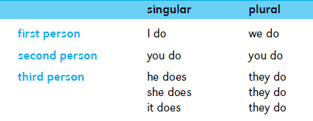

The simple past form of do is did.

I did my homework but forgot to take it to school.
Sally did her hair in front of the mirror.
The boys did very badly in their spelling test.
Paul and Roger did some magic tricks for us.
The children did the housework while their parents relaxed.

To make the negative form of verbs in the simple present tense, use do and does with not.

I do not have any brothers or sisters.
We do not want any more bread, thank you.
My brother and I do not like football.
You see beautiful mountains in Scotland but you do not see much sunshine.
Mom does not buy our food at that supermarket.
Jenny does not eat lunch at school because she does not like the food.
My cat does not make as much noise as your dog.

The simple past tense of does not and do not is did not. The contraction is didn’t.

Maggie did not have long hair when I first met her.
I got sunburned because I did not wear my hat.
The teacher didn’t give us any homework.
Mom and Dad didn’t buy me a cell phone for my birthday.
You didn’t take the dog for a walk last night.

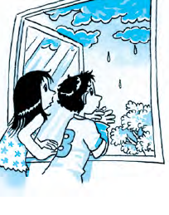
The Infinitive
The infinitive is the base form of a verb. It is often preceded by the word to.
Infinitives often appear after other verbs.

The rain began to fall.
Sally and I agreed to meet this afternoon.
I’ve arranged to see the doctor at 3 o’clock.
I hope to visit Disneyland someday.
I like to ride my bike in the street.
My parents have decided to buy a new car.
Paul is learning to swim.
I didn’t mean to upset you.

Some verbs have an object before the infinitive. In these examples the objects are printed in colour.

Simon asked me to help him.
The teacher told us not to run in the corridor.
Susie persuaded her friends to play on the team.
The manager allowed the staff to leave early.

Infinitives often appear after adjectives. In these examples the adjectives are printed in colour.

The boys were afraid to cross the busy road.
I’m very pleased to see you again.
This problem will be difficult to solve.
The shelf is too high to reach.
Don’t you think it’s rude to ignore the new girl in class?
The experiment was interesting to watch.
You’re welcome to come with me.

You can also use infinitives after some nouns and pronouns to say what you are using something for.

Take a book to read.
I phoned for a taxi to take us to the airport.
Has everyone got something to drink?
I’ve got lots of nice clothes to wear.
Find a space on the floor to sit in.

Infinitives sometimes follow words like how, what, which and where.

My brother is learning how to cook.
I can’t decide which to choose—the ice cream or the pudding.
I don’t know what to say.
Sally can’t remember where to hang her coat.

Infinitives are also used after helping verbs such as will, can, should, may and must. After these helping verbs use infinitives without the word to.

I can swim.
We think she will win the race.
You must try harder.
Do you think we should wait?
May I come in?

The Imperative Form of Verbs
When you give an order or command, use the base form of a verb, such as give, read or come. This base form is called the imperative.

Open your books to page 25.
Stop and look before you cross the road.
Come to the front of the class.
Show me your homework.
Read the first sentence out loud.
Choose a partner and stand in a circle.

Imperatives are very direct. To be more polite, you can use please before the imperative.

Please show me your homework.
Please read the first sentence out loud.
Please come to the front of the class.

To make negative imperatives, use do not or don’t before the base form of the verb.

Do not bring calculators into the exam room.
Please don’t change anything on my computer.

