Direct and Indirect Speech Exercises
Exercise 1
Fill in the blank spaces with a verb in the correct tense. The first one has been done for you.
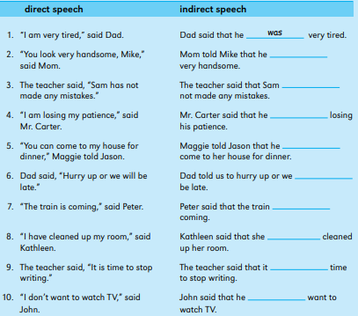

Exercise 2
Complete these indirect speech sentences with the correct pronoun or determiner. The first one has been done for you.
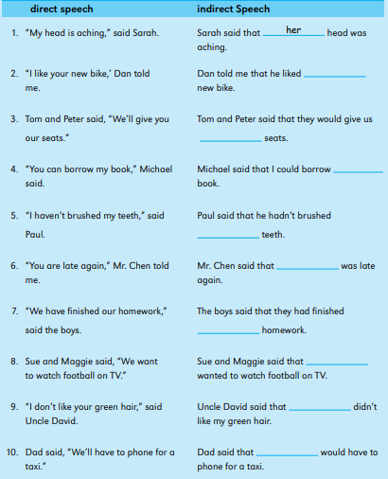
Exercise 3
Rewrite the following sentences as indirect questions or indirect commands. The first one has been done for you.
