Verbs and Tenses Exercises
Exercise 1
Exercise 1
Read the following sentences. Identify the verb in each sentence.

1. We live in an apartment on the boulevard.
2. Some children learn very fast.
3. We go for swimming lessons on Sunday.
4. I like my new bike.
5. Babies sometimes sleep during the day.
6. My dad buys a newspaper every morning.
7. These dolls belong to Kathleen.
8. I often walk to school with my dad.
9. My sister plays the piano very well.
10. Sarah sometimes reads in bed at night.
Exercise 2
Fill in the blank spaces with the third person singular form of the verbs in the space.

Example: Ali (look) looks sad today.

1. Sumiko (speak) _____ English very well.
2. Mr. Kim (come) _____ to school on his motorbike.
3. My neighbour’s dog (bark) _____ very loudly.
4. My little brother always (brush) _____ his teeth properly.
5. Dad is so tall that his head almost (touch) _____ the ceiling.
6. Our dog (catch) _____ the ball in its teeth.
7. Mum (mix) _____vinegar and oil to make salad dressing.
8. Sally (try) _____ not to disturb her brother when he’s reading.
9. Dad (buy) _____ his newspaper from the store on the corner.
10. Her music (annoy) _____ me when I’m doing my homework.
Exercise 3
Underline the verbs in the following sentences. Then show whether the verb is transitive
or intransitive by putting a checkmark (✓) in the correct box. Remember that depending
on the meaning, some verbs can be either transitive or intransitive. For each of the
transitive verbs you have marked, write the object of the verb on the lines. The first one
is done for you.
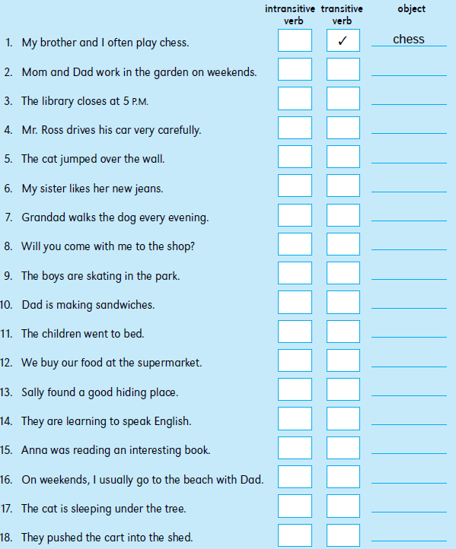

Exercise 4
Look at the pairs of subjects and verbs below. Then write a sentence using each subject
with the simple present form of the verb. Remember that you can also use the simple
present tense to talk about the future.

Example: Dad goes to work on his bike.

subject verb
1. Dad go
2. My brother ride
3. The dog watch
4. The bus leave
5. Tom and Sam buy
6. We eat
7. Aunt Grace come
8. Our neighbour like
9. The boys start
10. My family travel

Exercise 5
Complete the following sentences by writing am, is or are in the blank spaces.

1. The weather ______ beautiful today.
2. All the children ______ on the playground.
3. Boys! You______ always late for class.
4. ______ you on the basketball team, too?
5. Nobody in my class______ interested in football.
6. ______this computer more expensive than that one?
7. Sally______ my best friend.
8. Mum and Dad ______ downstairs watching television.
9. Paul and Henry______ in the computer room.
10. The Eiffel Tower ______ the tallest monument in Paris.

Exercise 6
Read the following passage. Fill in there’s, there are, there isn’t or there aren’t in the
blank spaces.

I like playing in our park because ______ some great things to play on.
______ a big chute to slide on and a huge sandbox to play in. ______
also some swings. Dogs are not allowed in the park so ______ no dogs to bother us.
______ also a lot of space for us to run around. It sometimes gets hot because ______
many trees to give shade, but ______ a fountain where we can drink
water. It’s the best place in the town for children. ______ another place as good as
the park.

Exercise 7
Rewrite the following sentences using contractions. The first one has already been
done to help you.
1. It is another sunny day today. It’s another sunny day today.
2. This is my sister. She is five.
3. I am not very interested in sports.
4. She is not my best friend. You are my best friend.
5. Cats are not as noisy as dogs.
6. We are busy doing our homework.
7. She is busy cleaning the car in the garage.
8. Our teacher is not very tall.
9. My parents are not home from work yet.
10. My friend is not very good at maths.

Exercise 8
Fill in the blank spaces with the present progressive tense of the verbs in parentheses.
Try to use contractions such as I’m, she’s and they’re where you can.

1. We ______ (go) to the zoo tomorrow.
2. He ______ (fix) my bike in the garage.
3. I ______ (help) Mum in the kitchen.
4. My sister and I ______ (watch) television in our bedroom.
5. The train ______ (leave) in ten minutes.
6. They ______ (come) with us to the museum.
7. We ______ (paint) some pictures for Aunt Susan.
8. The boys and girls ______ (dance) in the hall.
9. The cat ______ (chase) some birds.
10. My brother ______ (tickle) me.

Exercise 9
Complete the following sentences with either 1) the simple present form of the verb,
or 2) the present progressive form of the verb.

1. The teacher always ______ (give) us interesting project work.
2. The wind ______ (blow) very strongly today.
3. I ______ (like) chocolate ice cream.
4. Be quiet! We ______ (try) to listen to the radio.
5. Let’s go inside now. It______ (begin) to rain.
6. Penguins ______ (eat) fish.
7. Dad never ______ (let) us play in the street when it’s dark.
8. The children ______ (go) swimming every day.
9. We’re trying to catch the ball that ______ (roll) down the hill.
10. My teacher (know) a lot about plants and animals.

Exercise 10
Write each past tense verb below under the correct heading.
laughed lived smiled landed
cried pinned hurried played
hopped tried grabbed raced

verb + ed verb + d double the last letter + ed change y to i and add ed

Exercise 11
Complete the sentences with the simple past tense of the verbs in space.

1. The boys ______ (whisper) secrets to each other.
2. Uncle Ben ______ (hurry) to catch his bus.
3. We ______ (return) our books to the library.
4. She ______ kiss) the frog and it (change) into a prince.
5. Someone ______ (tap) me on the shoulder.
6. The baby ______ (cry) when we took her toy away.
7. John ______ (pin) the badge onto his jacket.
8. Two doctors ______ rush) into the room.
9. This is the house that we ______ (live) in when I was younger.
10. Grandad ______ (lower) himself into the chair.

Exercise 12
Write was or were in the blank spaces in the following passage.

It ______ a beautiful summer’s day and there______ n’t a cloud in the sky. Mum, Dad and I______ all in the garden. Dad ______in the vegetable garden planting some seeds and Mum and I______ busy with other jobs. The sun______ hot and soon I ______feeling very tired. Mum and Dad______n’t tired at all. They went on working for a long time. I ______
glad when it ______ time to go inside and have a drink.

Exercise 13
Identify the correct past tense verb in each sentence below.

1. I (losed / lost) my watch in the park.
2. David (hurt / hurted) his knee when he (falled / fell).
3. I kicked the ball hard and it (breaked / broke) a window.
4. My new shoes (cost / costed) a lot of money.
5. I (getted / got) this book from the library.
6. We had a garage where we (keeped / kept) our car.
7. Ali (shew / showed) me the cut on his knee.
8. The glass (falled / fell) off the table and (breaked / broke).
9. We (selled / sold) our old car and (buyed / bought) a new one.
10. The bell (ringed / rang) and we all (goed / went) into school.
11. The dog (catched / caught) the ball in its mouth.
12. The man (kneeled / knelt) down to talk to the little boy.
13. I (meeted / met) my friend in the park.
14. Our cat (runned / ran) onto the road in front of a car.
15. Jane (writed / wrote) a letter to her best friend.

Exercise 14
Complete the sentences with the past progressive tense of the verbs in the space.

1. At the block party lots of people ______ (dance) in the street.
2. I ______ (sit) in my bedroom reading a book.
3. Someone ______ (make) a very loud noise in the street.
4. Why you all ______ (laugh) when I came in?
5. Mike and John ______ (wash) their paintbrushes.
6. Sally ______ (practice) the piano.
7. I ran so fast that my heart ______ (beat) really hard.
8. Our neighbours ______ (have) a barbecue.

Exercise 15
Complete the following sentences with has or have.
1. My dog ______ a long shiny coat.
2. Our teacher ______ a very kind face.
3. You ______ a lot of homework to do.
4. Sam and I ______ desks near the front of the class.
5. Paul ______ two brothers and a sister.
6. My friend Andy ______ a big house.
7. Mice ______ long tails.
8. Most dogs ______ sharp teeth.
9. I ______ more toys than my friend .
10. These flowers ______ a strange smell.

Exercise 16
Complete the sentence with the present perfect tense of the verbs.

1. The children ______ (make) the house very messy.
2. I (______ see) that actor in several movies.
3. The boys ______ (drink) all the soda in the refrigerator.
4. Our dog ______ (hurt) its leg.
5. One of the workmen ______ (fall) off his ladder.
6. She’s sad because her friends ______ (go) to the park without her.
7. Dad ______ (have) a shower already.
8. I’ve been shouting so much that I ______ (lose) my voice.
9. My sister’s boyfriend ______ (buy) her a diamond ring.
10. Alan ______ (do) this jigsaw puzzle so many times that he could do it with
his eyes shut.

Exercise 17
Identify the correct past participle in each sentence below.
1. Your child has (broke/broken) my window!
2. Have you (eaten/ate) all your dinner?
3. I have (known/knew) Sally since we were in nursery.
4. Michael has (drew/drawn) a picture for his grandad.
5. The new girl seems nice, but I haven’t (spoke/spoken) to her yet.
6. We’ve (drank/drunk) all the milk.
7. The ball has (went/gone) over the garden fence.
8. Has Tom (did/done) all his homework?
9. You have (been/was) late for school every day this week.
10. Help! I’ve (fell/fallen) down a hole!

Exercise 18
Decide whether shall and will are used correctly in each sentence.

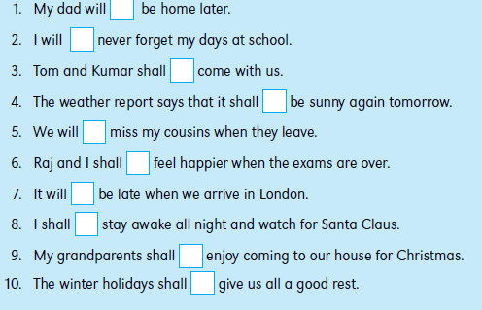

Exercise 19
Read the pairs of subjects and verbs below. Then write sentences about future events
using the correct form of be going to. For example, for the first sentence you could write:

My friend Tom is going to sleep at my house tonight.
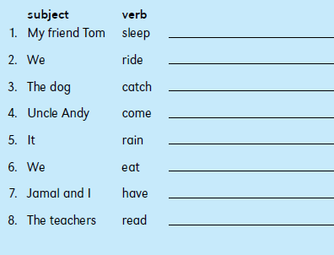
Exercise 20
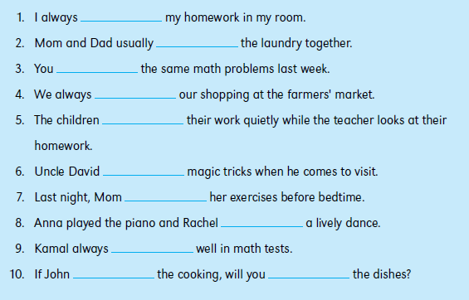
Complete the following sentences with do, does or did.

Exercise 21
Complete the following sentences with the contractions don’t, doesn’t or didn’t.
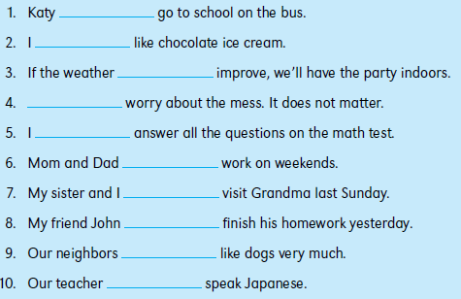

Exercise 22
Look at the following half-sentences that contain adjectives. Complete each sentence
with an infinitive. For example, for the first sentence you could write:
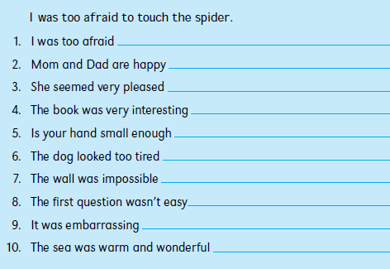

Exercise 23
Study the following pairs of verbs and nouns. Then write a sentence using each pair
with the verb as an imperative. Try to use negatives in some of your sentences. For the
first pair, you could write:
