Pronouns Exercises
Exercise 1
Read the following passage. Write the missing subject and object pronouns in the
blank spaces.
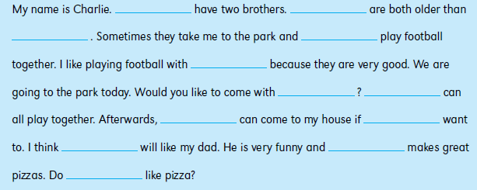

Exercise 2
Some of the reflexive pronouns in the following sentences are used correctly, but some
are not.
Decide if the reflexive pronoun is correct or not correct.
1. Sometimes I wash the dishes all by himself .
2. Dad had an accident. He cut herself with a knife.
3. Sally washes the car by herself .
4. Do you think the doctor can cure itself when he is ill?
5. The cat stays clean by licking itself .
6. Anna and May made the dinner all by herself .
7. Mom lets me walk to school by myself .
8. Can you dress themselves , boys and girls?
9. David can swim all by himself now.
10. This light is automatic. It switches itself on at night.

Exercise 3
Write a short sentence using each of the interrogative pronouns below. There is an example completed for ‘who?’
- Who- who is this man?
- Whose
- What
- Which
- Whom

Exercise 4
Read the following passage. Write the missing demonstrative pronouns in the blank
spaces.

Henry and I went for a walk on the beach. “What’s ________ over there?” I asked. “It
looks like broken glass,” said Henry. He gave me a bag. “Put it in ________,” he said. I
put the broken glass into the bag. “We’d better put ________ in the bin,” I said. He
took the bag from me. “You have to hold it like ________,” said Henry, “so that you
don’t cut your hand.”
Exercise 5
Write the missing possessive pronouns in the blank spaces to complete the sentences.
1. I chose this seat first so it’s ________.
2. Can we borrow your colouring pens? We’ve lost ________.
3. We live in the city and they live in the countryside. Our house is smaller than ________.
4. John, is this pencil ________?
5. Sally is looking for her gloves. Are these gloves ________?
6. Can Julie use your bike? ________is broken.
7. Tom got the books mixed up. He thought mine was and his was________.
Exercise 6
Identify at least one indefinite pronoun in each sentence.

1. One never knows who might be listening.
2. Many are called but few are chosen.
3. I finished my cookie and asked for another.
4. Both were punished for the crime they committed.
5. Several applied for the job, but no one was hired.

