Punctuation Exercises
Exercise 1
Put the correct punctuation mark at the end of each sentence.
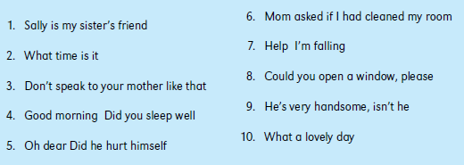
Exercise 2
Rewrite the following sentences by putting commas and apostrophes in the correct
places.
Exercise 3
Put capital letters in the correct places as you rewrite these sentences.
