Sentences Activities
Exercise 1
Tell whether each sentence below is a declarative sentence, an interrogative
sentence, an exclamatory sentence or an imperative sentence.
The first one has been done for you.
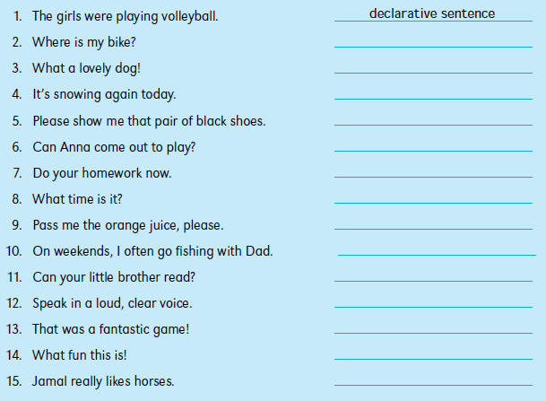
Exercise 2
Underline the verbs in these sentences. Then tell whether each verb is transitive or
intransitive. Put a checkmark in the correct box.
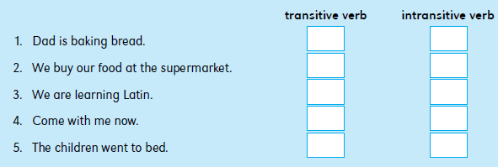

Exercise 3
Underline the objects in the following sentences. Write D for direct object or I for indirect object above each one. The first one has been done for you.
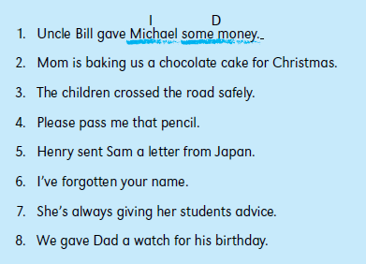

Exercise 4
All the following sentences have verbs with direct objects. Rewrite each sentence,
adding an indirect object to it. For example, for the first sentence you could write:
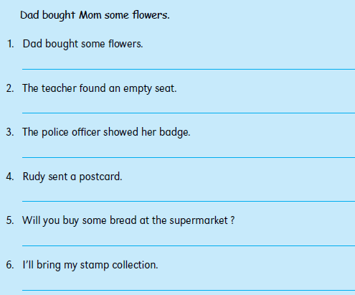

Exercise 5
Are the following sentences simple sentences or compound sentences? Put a
checkmark (✓ ) in the correct box. For each compound sentence you marked, write the
conjunction in the blank space next to it. The first one has been done for you.
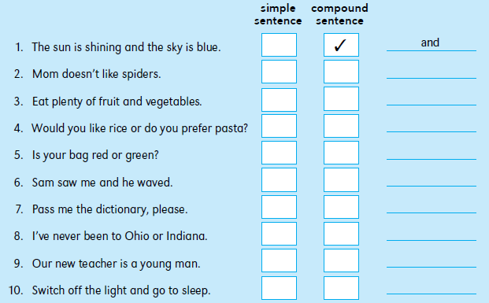

Exercise 6
Match the if-clauses in the box with the main clauses below. Write two sentences for
each pair of clauses. The first one has already been done for you.
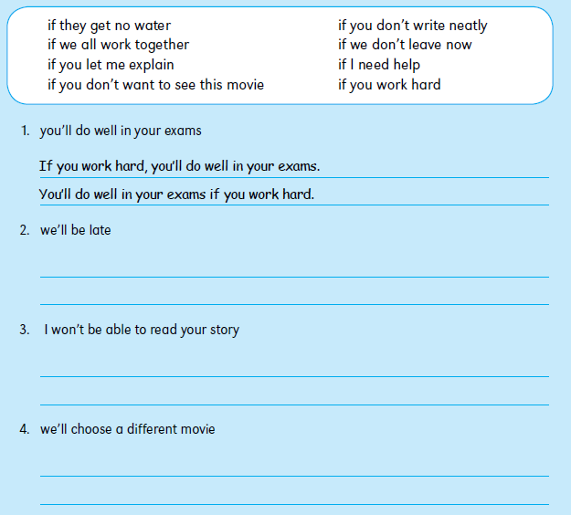
Exercise 7
Rewrite the following sentences to make them negative. Use negative words such as
no, not and never. Use contractions in some of your sentences. The first one has been
done for you.
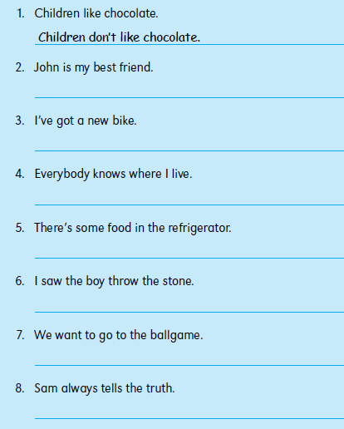

Exercise 8

Rewrite the following statements as yes or no questions. The first one has already
been done for you.
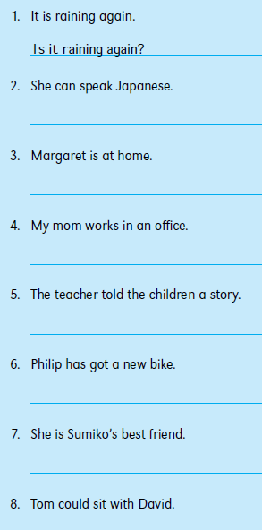
Exercise 9
Choose one of the question words from the box to complete the sentences below.
You may use some of the words more than once. The first one has been done for you.
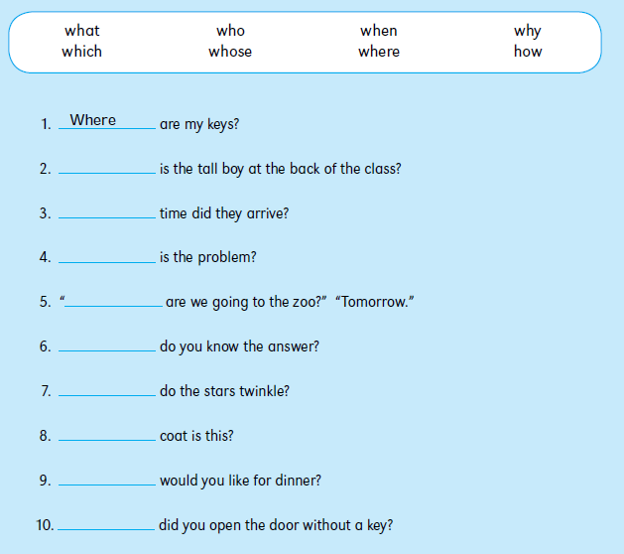
Exercise 10
Complete the following sentences by adding a question tag. Remember that a positive
sentence needs a negative question tag, and a negative sentence needs a positive
question tag. The first one has been done for you.
