Exercise 1

Read the following passage and underline the adjectives. Identify adjectives
of size, identify adjectives of colour, identify adjectives of quality and identify
adjectives of origin.

Sydney is a large Australian city with busy streets and expensive shops. In summer, it’s a very hot place. People wear cool clothes and drink cool drinks. There are beautiful sandy beaches where people can rest and look up at the wide blue sky. There are big parks for tourists to visit. Japanese tourists like to sit and watch other people. British tourists take photographs of the strange plants and colourful birds.

Exercise 2

The following passage contains a lot of adjectives. Some of the adjectives appear in the
wrong order. Identify the wrongly ordered adjectives, then write them in their
correct order.

My friend Jeremy is a handsome tall boy. He always wears a white long T-shirt and a big red
cap. He carries a blue huge canvas bag to school. His favourite food is red crunchy apples
and he always has one in his bag. Our teacher is an English kind tall man called Mr. Clark.
He wears a blue smart suit and glasses with black plastic thick frames.

Exercise 3

The following sentences contain adjectives made by adding endings to nouns. Write the
noun that each adjective comes from on the line after each sentence. The first one has
been done for you. Remember that some nouns must be changed slightly before the
ending is added.

1. She’s always making careless mistakes. care
2. It was a very painful injury.
3. Witches and wizards have magical powers.
4. These oranges are very juicy.
5. Dogs are usually more energetic than cats.
6. Our neighbours are not very friendly.
7. She keeps her toys in a large wooden box.
8. Take off your muddy shoes before you come in.
9. May I borrow your pencil sharpener? Mine is useless.
10. What a beautiful dress!

Exercise 4

Fill in the blank spaces with adjectives made from the verbs in parentheses. Remember
that both present participles and past participles can be used as adjectives. Choose
the adjective that suits the sentence best. The first one has been done for you.

1. It wasn’t a very interesting (interest) movie.
2. We could hear the_________ (excite) fans screaming.
3. I hope the pupils don’t think that my classes are _________ (bore).
4. My dad had a very _________ (worry) look on his face.
5. Have the police found the _________ (steal) car yet?
6. The supermarket sells lots of _________ (freeze) food.
7. The players on the _________ (win) team don’t look tired at all.
8. Some of the old houses had _________ (break) windows.

Exercise 5
Read the following passage. Write the correct comparative and superlative forms of
the adjectives in parentheses in the blank spaces. The first one has been done for you.

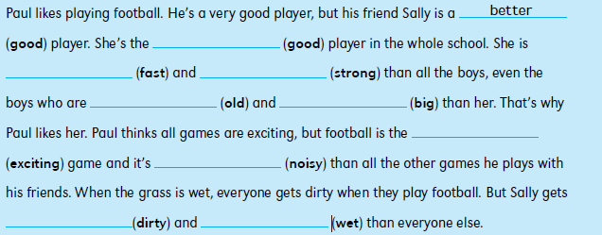

Exercise 6
Complete the following sentences. Write an adjective phrase that includes the
preposition in parentheses. The first one has been done for you.

Exercise 7
Complete the following sentences. Write an adjective phrase, using the adjective in
parentheses and another adjective linked with and or but. The first one has been done
for you.

